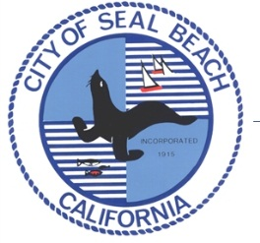
PRESS RELEASE

Seal Beach Police Department
911 Seal Beach Blvd
Seal Beach, CA 90740

April 13, 2016 Contact: Sgt. Michael Henderson
Phone: (562) 799-4100 ext. 1160

FOR IMMEDIATE RELEASE Email: mhenderson@sealbeachca.gov

***PRESS RELEASE***
Seal Beach, Ca. – Road Closures for the Seal Beach Classic Car Show, April 30th.
The Annual Classic Car Show is the showcase event for the City of Seal Beach Chamber of Commerce, with over 500 classic cars on display all along Main Street.
Main Street will be closed between Pacific Coast Highway and Ocean Avenue, Ocean Avenue between 10th and 8th St., Central Ave. between 10th St. and 8th St. and Electric Ave. between 10th St. and 8th St. On the day of the show, Saturday, April 30th, the streets will close at 5:00 a.m. The cars will enter the show via Ocean Avenue, Central Avenue and Electric Avenue starting at 6:00 a.m. The show is open to the public from 10:00 a.m. through 4:00 p.m. At that time, the show is over and the streets will reopen.
Parking for the general public will be on the grounds of the Seal Beach Naval Weapons station. Entry to the Naval Weapons Station parking area is on Seal Beach Boulevard, south of Pacific Coast Highway. Do not go to the Main Gate or to the gate on Westminster Bl.
If you need additional information, please call the Chamber of Commerce at 562-799-0179.
# # #

